1. Introduction
The start-up of a Linux operating system follows a step-by-step process. This process starts with the power on or by running a command in the terminal:
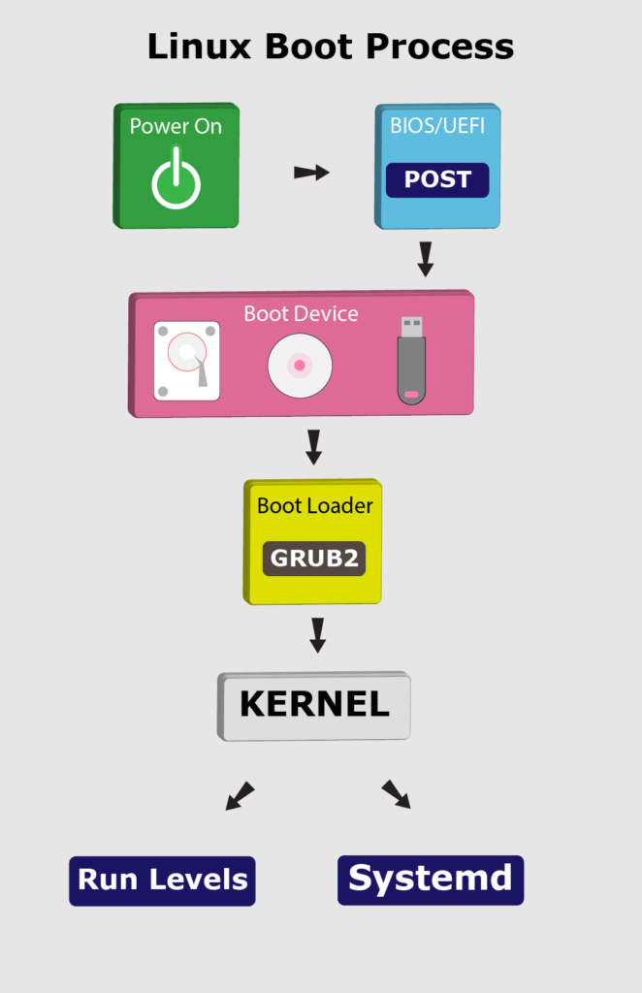
In this tutorial, we’ll go through the booting steps of a Linux system.

2. BIOS and UEFI
First, the BIOS (Basic Input/Output System) or UEFI (Unified Extensible Firmware Interface) program kicks in once the system powers up. Usually, the BIOS contains all the code to gain initial access to the main machine devices:
- keyboard
- display screen
- disk drives
- serial communications
However, most of these devices will have dedicated device drivers taking over once the system boots fully.
BIOS and UEFI are firmware interfaces that computers use to boot up the operating system (OS). Yet, the two programs differ in how they store metadata on and about the drive:

- BIOS uses the Master Boot Record (MBR)
- UEFI uses the GUID Partition Table (GPT)
Next, the BIOS or UEFI runs the power-on self-test (POST). The POST does a series of tasks:
- verify the hardware components and peripherals
- carry out tests to ensure that the computer is in proper working condition
Further, if this test finds any error, it commonly shows an error message on the screen. In case the test fails to detect the RAM, POST triggers a beeping sound.
Finally, if the system passes the POST, it signals the start-up process to the next stage.

3. Boot Loader
Now, the BIOS or UEFI has run the POST to check the state of the machine. Moving on, the BIOS/UEFI selects a boot device depending on the system configuration. Usually, there’s a default boot order:
- Hard drives
- USB drives
- CD drives
Of course, we can configure the BIOS or UEFI to choose the boot device in any order. Whatever their order, the computer looks for the boot loader in these devices one by one.

In fact, a BIOS system has the boot loader located in the first sector of the boot device; this is the MBR. It takes up the first 512 bytes on the disk. On the other hand, a UEFI system stores all startup data in an .efi file. The file is on the EFI System Partition, which contains the boot loader.
For example, we can use fdisk to check the system partition on our machine:
$ fdisk -l
Disk /dev/nvme0n1: 232.91 GiB, 250059350016 bytes, 488397168 sectors
Disk model: Samsung SSD 960 EVO 250GB
Units: sectors of 1 * 512 = 512 bytes
Sector size (logical/physical): 512 bytes / 512 bytes
I/O size (minimum/optimal): 512 bytes / 512 bytes
Disklabel type: gpt
Disk identifier: 6907D1B3-B3AB-7E43-AD20-0707A656A1B5

Device Start End Sectors Size Type
/dev/nvme0n1p1 2048 1050623 1048576 512M EFI System
/dev/nvme0n1p2 1050624 34605055 33554432 16G Linux swap
/dev/nvme0n1p3 34605056 488397134 453792079 216.4G Linux filesystemCopy
Notably, the boot loader is a small program that loads the operating system. The main job of the boot loader is to perform three actions with the kernel: locate on the disk, insert into memory, and execute with the supplied options.
The following are some of the available boot loaders for a Linux system:
- LILO
- SYSILINUX
- GRUB2
In general, once the computer finds the boot loader on a device, it will run it. Consequently, this loads a larger and more complex program which eventually starts our operating system.

